1. What do you mean by cells in an excel sheet?

Answer:

It is an object of Excel worksheets Whenever you open Excel, the Excel worksheet contains cells to store the information in them.  You enter content and your data into these cells. Cells are the building blocks of the Excel worksheet. So, you should know every single point about it.

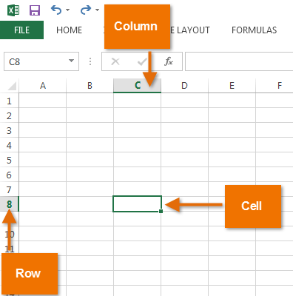

2.How can you restrict someone from copying a cell from your worksheet?

Answer:

**STEPS:**

* + First, go to the Review tab. From the Protect option of the ribbon, select the option [Protect Sheet](https://www.exceldemy.com/excel-worksheet-vs-workbook-level-protection/).
  + 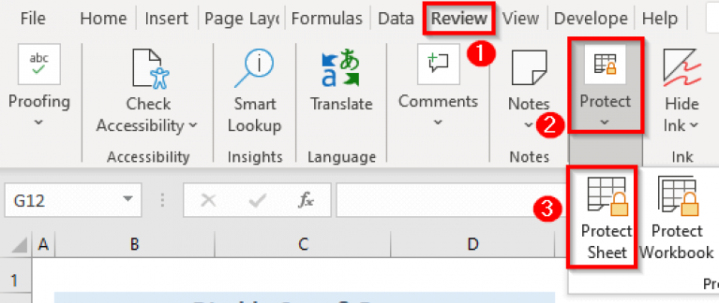In short: Go to Review > Protect > Protect Sheet
  + Now, a new dialogue box named “Protect Sheet” will appear.

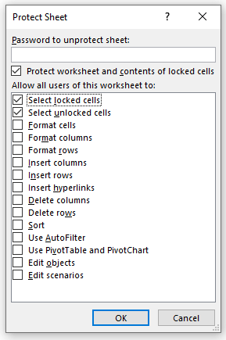

* Next, insert a password in the box named **“Password to unprotect sheet”**.
* Then, uncheck the options **“Select locked cells”** &**“Select unlockecells”**.
* Now, press **OK**.

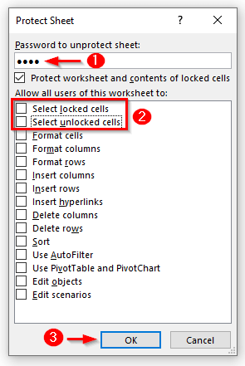

* After that, a new dialogue box will appear named **“Confirm Password”**.
* Type the password again in the box named **“Re-enter password to proceed”**.
* Then, press **OK**.

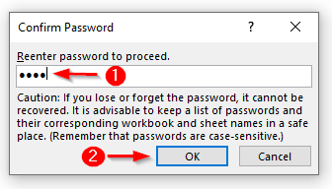

* Finally, after the above actions if you try to select or copy and paste any cell from the worksheet you will see the following message box.

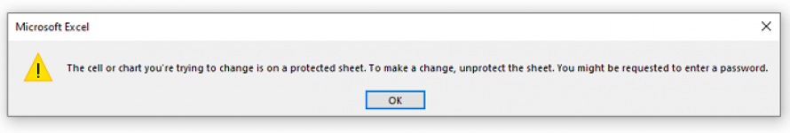

3. How to move or copy the worksheet into another workbook?

Answer

The common way to copy a sheet to another workbook is this:

* 1. Right click on the tab that you want to copy, and then click Move or Copy…
  2. In the Move or Copy dialog box, do the following:
  + Under To book, choose the target file. To place a copy into a new workbook, select (new book).
  + Under Before sheet, specify where to put the copy.
  + Select the Create a copy box.
  + Click OK.

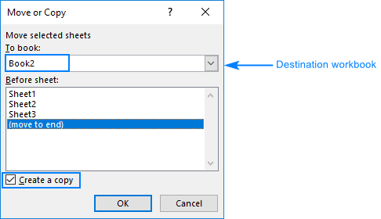

4. Which key is used as a shortcut for opening a new window document?

Answer

|  |  |
| --- | --- |
| 1. To create a new workbook | Ctrl + N |
| 2. To open an existing workbook | Ctrl + O |

5. What are the things that we can notice after opening the Excel interface?

Answer

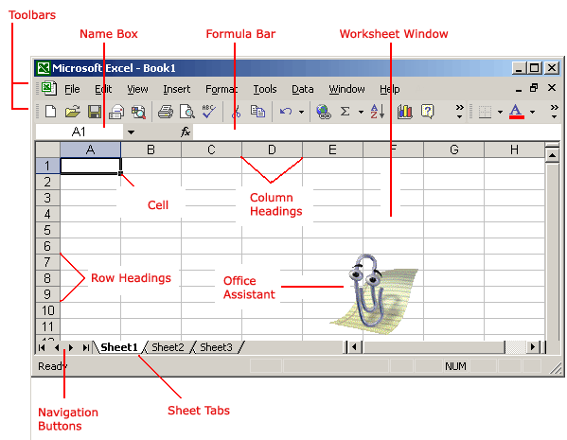

6. When to use a relative cell reference in excel?

Answer

By default, a cell reference is a relative reference, which means that **the reference is relative to the location of the cell**

**When we want to change the location of column as well as row in formula**

**At that time, we use relative cell reference**